(i) Train dataset size = 1343 samples

(ii) Validation dataset size = 336 samples

(iii) Test dataset size = 268

|  |  |  |  |  |
| --- | --- | --- | --- | --- |
| **S.No** | **TOPIC** | **Link** | **Author** | **Review** |
| 1. | FLOOD PREDICTION USING MACHINE LEARNING MODELS: LITERATURE REVIEW. | <https://www.mdpi.com/2073-4441/10/11/1536> | [Amir Mosavi](https://www.researchgate.net/profile/Amir-Mosavi-3)  [Pinar Ozturk](https://www.researchgate.net/profile/Pinar-Ozturk): [Norwegian University of Science and Tech](https://www.researchgate.net/institution/Norwegian-University-of-Science-and-Technology2)  [Kwok Wing Chau](https://www.researchgate.net/profile/Kwok-Chau): [The Hong Kong Polytechnic University](https://www.researchgate.net/institution/The_Hong_Kong_Polytechnic_University) | Describe the brief information about how the Flood analysis helps us to overcome the damage and reduce the chances of loss cause by flood. |
| 2 | FLOOD PREDICTION USING MACHINE LEARNING MODELS: | <https://www.researchgate.net/publication/335094911_Flood_Prediction_Using_Machine_Learning_Models_Literature_Review> | [Amir Mosavi](https://www.researchgate.net/profile/Amir-Mosavi-3)  [Pinar Ozturk](https://www.researchgate.net/profile/Pinar-Ozturk): [Norwegian University of Science and Tech](https://www.researchgate.net/institution/Norwegian-University-of-Science-and-Technology2)  [Kwok Wing Chau](https://www.researchgate.net/profile/Kwok-Chau): [The Hong Kong Polytechnic University](https://www.researchgate.net/institution/The_Hong_Kong_Polytechnic_University) | Describe the information about the use of Machine Learning in Flood Analysis and use of best model of Ml to predict the probability of occurrence of flood. |
| 3 | A FLOOD PREDICTION SYSTEM DEVELOPED USING VARIOUS MACHINE LEARNING ALGORITHMS | <https://papers.ssrn.com/sol3/papers.cfm?abstract_id=3866524> | [Kwok Wing Chau](https://www.researchgate.net/profile/Kwok-Chau): [The Hong Kong Polytechnic University](https://www.researchgate.net/institution/The_Hong_Kong_Polytechnic_University) | Describe the methodology used in flood analysis. This paper clearly suggest to use SVM and Random Forest Classification for ML models |
| 4 | FLOOD FORECASTING USING MACHINE LEARNING METHODS | <https://www.researchgate.net/publication/331479872_Flood_Forecasting_Using_Machine_Learning_Methods> | [Fi-John Chang](https://www.researchgate.net/profile/Fi-John-Chang)  [National Taiwan University](https://www.researchgate.net/institution/National-Taiwan-University)  [Kuolin Hsu](https://www.researchgate.net/profile/Kuolin-Hsu)  [University of California, Irvine](https://www.researchgate.net/institution/University-of-California-Irvine)  [Li-Chiu Chang](https://www.researchgate.net/profile/Li-Chiu-Chang)  [Tamkang University](https://www.researchgate.net/institution/Tamkang-University) |  |
|  |  |  |  |  |
|  |  |  |  |  |
|  |  |  |  |  |
|  |  |  |  |  |

Dataset in folder Label Dataset

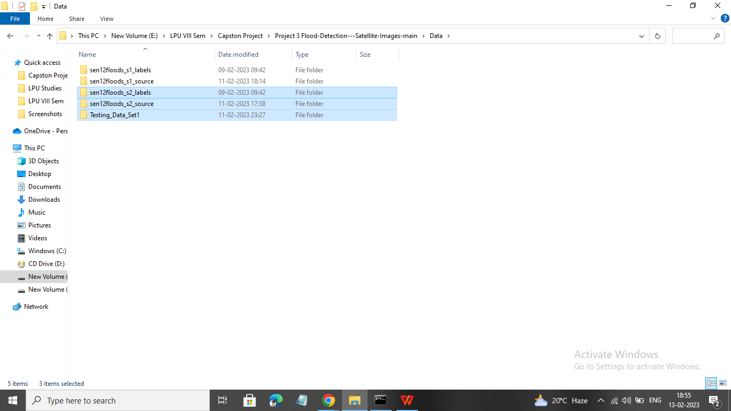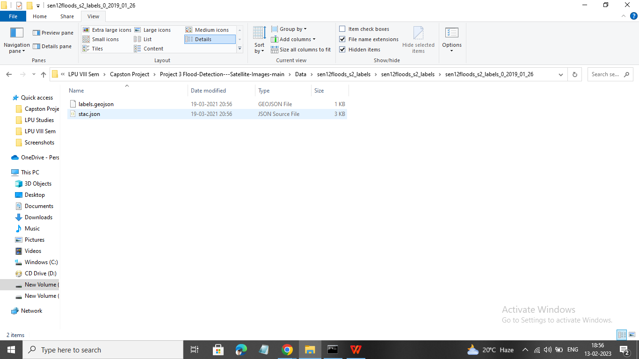

Source Data

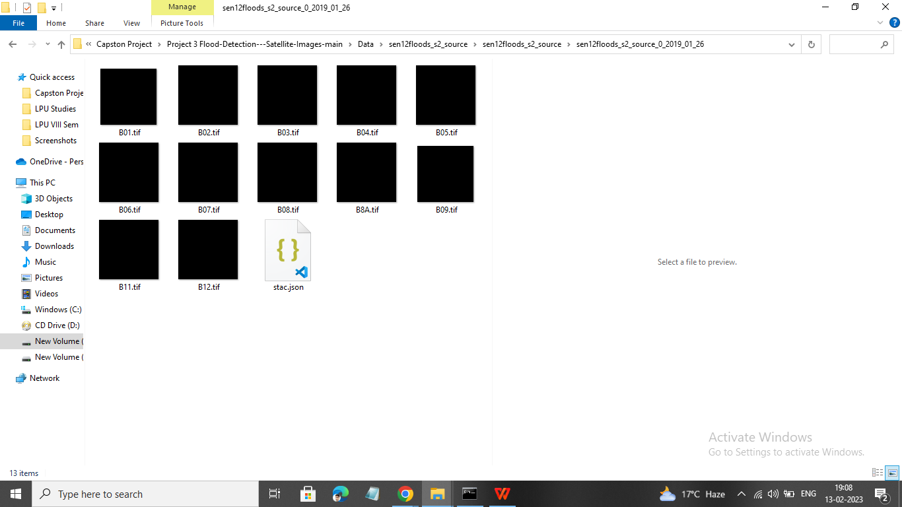

[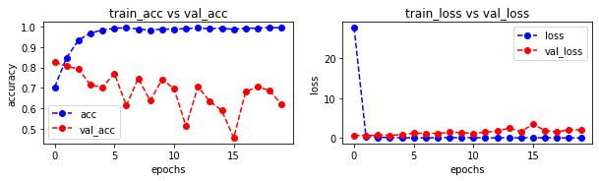](https://github.com/KonstantinosF/Flood-Detection---Satellite-Images/blob/main/images/model_evaluation.png)